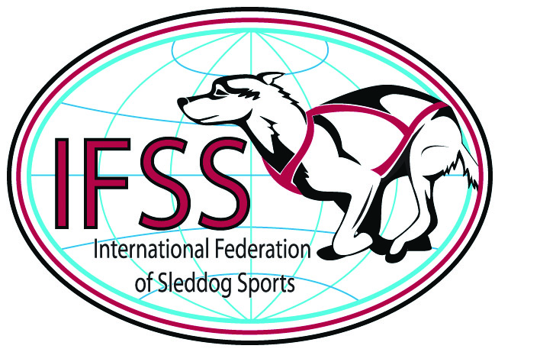
International Federation of Sleddog Sport

Invitation
European Championships 2014

Sprint and Mid. distance
Metsäkartano in Rautavaara,
Finland
7th to 9th of March 2014
General:
- Use of private snow scooters (skidoos) is not allowed.
- Entries via the national IFSS member federations only on the official entry forms.
Location:
Metsäkartano in Rautavaara, Finland
http://maps.google.fi Metsäkartano, Metsäkartanontie 700, 73900 Rautavaara
Start and finish are at Metsäkartano in Rautavaara
Categories and Distances:
Sprint (Nome Style):
- Unlimited classes (SPU) 24 km
    - 8-dog class (SP8) 16 km
- 6-dog Class (SP6) 13 km
- 4-dog Class (SP4 + 4SS) modified for Arena race model, see below 7,5 km
- 4-dog Junior class (SP4J) 7,5 km
This class, reserved for juniors drivers between the age of 14 and 16 years, shall be run as a separate class according to the IFSS Race Rules.

The following modification to apply in 4-dog Class (SP4) due to Arena race model
Day 1: SP4
Two-day race using interval start method the first day on standard trail distances.
Day 2: SP4
The second day of the Two-day race using persuit start method on day two, depending on the day 1 result. The first to cross the finish line will be awarded European Champion in this class.
Day 3: 4SS
Arena race with a mass start on a short track with 2 laps. The first to cross the finish line will be awarded European Champion in this class.

Mid.distance
- Unlimited class (UMD) 42 km A limit of 12 dogs out of a pool of 14 dogs
- 6 dog class (LMD) 42 km A limit of 6 dogs out of a pool of 8 dogs

Sprint Ski-dogs
Day 1:
Skijoring one-dog classes
- Seniors divided into men and women (NMS1/NWS1), distance 12 – 18 km.
- Juniors divided into men and women (NMSJ/NWSJ), distance 8 – 12 km.
Day 2:
Combined competition in one-dog class modified for Arena model. Arena race with mass start on a short track with 2 laps. The first to cross the finish line will be awarded European Champion in this class.
- Seniors divided into men and women (NMC/NWC); distance 2x7,5 km
- Juniors divided into men and women (NMCJ/NWCJ); distance 4x2,7km, as per IFSS Regulations

Day 3:
Relay (NR); distance 3x7,5 km, Mixed pulka/skijoring. Three legs; the first and second legs to be skijoring and the last leg to be pulka.

All classes are open for a limited number of teams from countries not represented in IFSS. Those teams will not be granted EC titles. Special awarding for registered nordic breed teams is foreseen.
Information and Room reservation:
For information and booking please look at EC-homepage http://ec2014.vul.fi/accommodation.html.
Race confirmation may be obtained via the IFSS Internet homepage: www.sleddogsport.net.
REGISTRATION:
The registration of qualified drivers, name and DID no., shall be received by the IFSS Europe Sport Committee on the entry form (see the IFSS Web site to download and use this form) on or before February 3rd 2014:
Nils H. Finsrud
Lyngveien 27,
NO-2636 Øyer
Norway
fax: + 47 61 05 51 01, email: sports@esdra.net

with a copy to IFSS VP Economy email: vp.economy@sleddogsport.net
Teams to be seeded and Registered Nordic Breed teams shall be marked on the entry formFor contestants in junior classes an IFSS Junior Waiver Form has to be submitted additionally.
Participation Fee:
Sprint:
unlimited class (US) 135 €
8 dog class (8S) 115 €
6 dog class (6S) 95 €
4 dog class (4S) (2 days) 95 €
4 dog class (4SS) Sprint 75 €
4 dog junior class (4J) 45 €
combined men one dog (MC1) 75 €
combined women one dog (WC1) 75 €
combined men junior one dog (MCJ) 45 €
combined women junior one dog (WCJ) 45 €
skijoring men one dog (MS1) 75 €
skijoring women (WS1) 75 €
skijoring men one dog junior (MSJ) 45 €
skijoring women one dog junior (WSJ) 45 €
nordic relay competition (NRC) 110 €

Mid. Distance:
unlimited class (UMD) 135 €
6 dog class (LMD) 135 €
The participation fee shall be paid, February 3rd 2014 at the latest, to the:

IFSS bank account Name & Address:
KBC Bank Bruxelles Louise,
AVENUE LOUISE 306,
1050 BRUXELLES, BELGIUM

Acc. name: | IFSS
Acc.Nr.: | BE89 7350 3332 9285
BIC: | KREDBEBB
IBAN: | BE89 7350 3332 9285

According to an IFSS Europe Sports Committee decision, late nominations and / or payments (received after February 3rd 2014) will double the participation fee!
EVENT Schedule (PROVISIONAL)
All the official meetings (Report on arrival of team leaders, team-leader meetings.) will be at:
THU. March 6th
10.00: Race Office opens – team leaders please report at your arrival: Metsäkartano/Vaasi
11.00: Veterinary check of dogs at the stake out area.
13.00: First team leader meeting: Metsäkartano/Kappeli
14.00: Trail inspection (team leaders only) Metsäkartano/Kappeli
17.00: Teams meet Metsäkartano/Kappeli
17.30: Opening ceremony: Metsäkartano / outside the main building
19.00: Dinner: Metsäkartano/Restaurant - to be ordered in advance 20 €
FRI. March 7th
08.00: Possible team leader meeting: Metsäkartano/Kappeli
09.00: Start, first day
17.00: Mandatory team leader meeting; Metsäkartano/Kappeli
SAT. March 8th
08.00: Possible team leader meeting: Metsäkartano/Kappeli
09.00: Start, second day
17.00: Mandatory team leader meeting Last entry for relay: Metsäkartano/Kappeli
20.00: Award ceremony of first and second day in connection with the dinner;
Metsäkartano/restaurant - to be ordered in advance 20 €
SUN. March 9th
08.00: Mandatory team leader meeting (last change to hand in the names for relay teams)
09.00: Start, third day
18.00: Final award and closing ceremony: Metsäkartano/restaurant

Race officials:
- Race marshal: Steinar Johansen
- Chief Judge Sprint/MD: Kari Tolkkila
- Chief Judge Nordic: Kati Kettumäki
- Race chief vet: Mervi Saviranta
- Local coordinator: Merja Tammi
- Trail Boss: Juha Hyvönen

Race regulations: see IFSS Race rules
http://sleddogsport.net/index.php?option=com_k2&view=item&layout=item&id=220&Itemid=578
Mandatory equipment and special rules in Middle distance classes:
- Unlimited class (UMD) A limit of 12 dogs out of a pool of 14 dogs.
- 6 dog class (LMD) A limit of 6 dogs out of a pool of 8 dogs.
Mandatory equipment in middle distance classes:
- A second snow hook for the unlimited class
- 4 booties per dog (either in the sled or in use)
- óne extra harness and one gangline, one pulling line and one neckline shall be in the mushers sled. Mobile phone in pocket is recommended
- An adequate braking pad (drag) as per race rule IFSS RR 41.2.2 for all Nome style classes.
Mandatory equipment in sprint classes:
- A second snow hook for the unlimited class and the 8 dog class in sprint.
- An adequate braking pad (drag) as per race rule IFSS RR 41.2.2 for all Nome style classes.
Doping tests for drivers and dogs may be performed.
The following list of forbidden substances will apply:
WADA list for humans and IFSS Anti-Doping Rules and Regulations
http://sleddogsport.net/index.php?option=com_k2&view=item&layout=item&id=364&Itemid=585
All dogs participating shall be identifited by micro chip before their arrival at the race site and shall be listed on the chipping form.
It is strictly forbidden to let dogs run loose at the stake out- & parking area during the event.
All participating nations shall appoint one team leader for the sprint championships . The team leaders shall be noted on the entry forms. Team leaders shall be present at the team leader meetings, in view of their liaison task between the race organizer and their team members.
Animal Welfare:
Participants shall meet the applicable requirements as per the IFSS RR Part VI

